38.15: a) 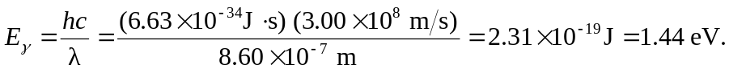
So the internal energy of the atom increases by
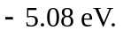
b)
So the final internal energy of the atom decreases to

